String x = in.nextLine();

#1

for (int i = 0; i < x.length(); i += 1) {

if (Character.isUpperCase(x.charAt(i))) {

out.print(x.charAt(i));

}

}

out.println();

#2

for (int i = 1; i < x.length(); i += 2) {

out.print(x.charAt(i));

}

out.println();

#3

for (int i = 0; i < x.length(); i += 1) {

if (x.charAt(i) == 'a' || x.charAt(i) == 'e' || x.charAt(i) == 'i'

|| x.charAt(i) == 'o' || x.charAt(i) == 'u'

|| x.charAt(i) == 'A' || x.charAt(i) == 'E'

|| x.charAt(i) == 'I' || x.charAt(i) == 'O'

|| x.charAt(i) == 'U') {

out.print("_");

} else {

out.print(x.charAt(i));

}

}

int counter = 0;

out.println();

#4

for (int i = 0; i < x.length(); i += 1) {

if (x.charAt(i) == 'a' || x.charAt(i) == 'e' || x.charAt(i) == 'i'

|| x.charAt(i) == 'o' || x.charAt(i) == 'u'

|| x.charAt(i) == 'A' || x.charAt(i) == 'E'

|| x.charAt(i) == 'I' || x.charAt(i) == 'O'

|| x.charAt(i) == 'U') {

counter += 1;

}

}

out.print(counter);

out.println();

#5

for (int i = 0; i < x.length(); i += 1) {

if (x.charAt(i) == 'a' || x.charAt(i) == 'e' || x.charAt(i) == 'i'

|| x.charAt(i) == 'o' || x.charAt(i) == 'u'

|| x.charAt(i) == 'A' || x.charAt(i) == 'E'

|| x.charAt(i) == 'I' || x.charAt(i) == 'O'

|| x.charAt(i) == 'U') {

out.print(i + ", ");

}

}

2a. **int**[] a = {1, 1, 1, 1, 1, 1, 1, 1, 1, 1 };

2b. **int**[] a = {1, 1, 2, 3, 4, 5, 4, 3, 2, 1};

2c. **int**[] a = {2, 3, 4, 5, 4, 3, 2, 1, 0, 0};

2d. **int**[] a = {0, 0, 0, 0, 0, 0, 0, 0, 0, 0};

2e. **int**[] a = {1, 3, 6, 10, 15, 19, 22, 24, 25, 25};

2f. **int**[] a = {1, 0, 3, 0, 5, 0, 3 , 0, 1, 0};

2g. **int**[] a = {1, 2, 3, 4, 5, 1, 2 , 3, 4, 5};

2h. **int**[] a = {1, 1, 2, 3, 4, 4, 3 , 2, 1, 0};

3.

int[] a = { 1, 2, 3, 12342143, 5, 4, 3, 2, 1, -32432 };

int max = a[0];

int min = a[0];

for (int integer : a) {

if (integer > max) {

max = integer;

}

if (integer < min) {

min = integer;

}

}

out.println(max);

out.println(min);

4.

int[] a = { 9, 7, 5, 2, -2 };

boolean isOrdered = true;

for (int i = 0; i < a.length - 1; i++) {

if (a[i] < a[i + 1]) {

isOrdered = false;

}

}

out.println(isOrdered);

5a. 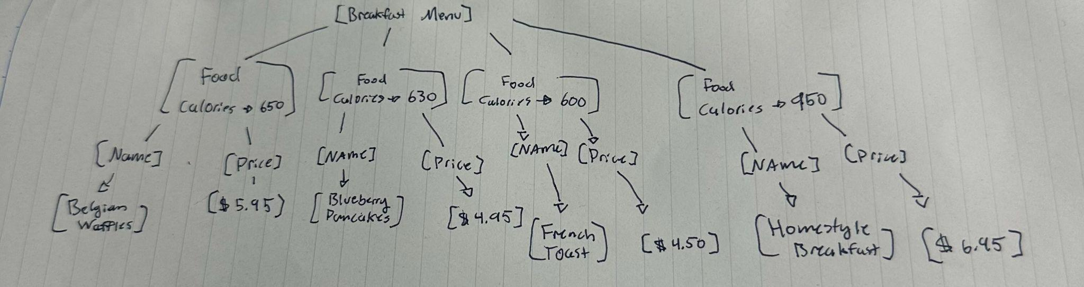

5b1. true

5b2. Breakfast menu

5b3. 4 children

5b4. False

5b5. Food [calories > 630)

5b6. True

5b7. “Food”

5b8. 2

5b9. True

5b10. 630

5b11. True

5b12. False

5b13. Name

5c.

<breakfast_menu>

<food calories="650">

<name price = "$5.95">Belgian Waffles</name>

</food>

<food calories="630">

<name price="$4.95">Blueberry Pancakes</name>

</food>

<food calories="600">

<name price = "$4.50">French Toast</name>

</food>

<food calories="950">

<name price = "$6.95">Homestyle Breakfast</name>

</food>

</breakfast_menu>

5d.

